<PROJECT NAME> Executive Summary

Airbnb data analysis software

**Group Members:**

|  |  |  |
| --- | --- | --- |
| Student Name | Student ID | Github ID |
| Zhanrui Liao | S5290972 | infinityJerryLiao |
| Chien Huang | S5333270 | ChienHuang0818 |
| Siqi Wu | S5312984 | wsq94317 |

# Abstract

This study focuses on an in-depth analysis of Airbnb's database, providing key insights and data trends to assist hosts and travelers in making informed decisions. The database analysis comprises five essential functionalities: **Property Information Query/ Histogram of Price Distribution/ Keyword Search/ Cleanliness Review Query/ Vacancy Rate Query Line Chart.**

These functionalities offer a deep understanding of Airbnb property data and provide valuable information for hosts and travelers to better plan and manage their accommodation experiences. The results of this study will contribute to making informed choices within the Airbnb community, enhancing overall accommodation quality.

# Introduction

The purpose of this report is to conduct an in-depth analysis of Airbnb's database, providing crucial insights and presenting data trends to assist both hosts and travelers in making informed decisions. We have set the date range for this analysis as 2018 and 2019, during which we executed various distinct analysis tasks. Specifically, our analysis includes the following functionalities:

1. Property Information Query: In this analysis task, we queried Airbnb data for the years 2018 and 2019 to obtain detailed information about different properties, such as room types, geographical locations, and amenities. We will present this information to help hosts better understand their properties and meet the needs of potential tenants.

2. Histogram of Price Distribution: We analyzed pricing data for 2018 and 2019 and created histograms to visualize the distribution of prices for Airbnb listings. This aid hosts and travelers in understanding the quantity of listings in different price ranges, facilitating their accommodation choices.

3. Keyword Search: This analysis task allows users to search for properties based on specific keywords or descriptions. We evaluated the effectiveness of keyword queries to ensure users can find properties that match their requirements.

4. Cleanliness Review Query: We analyzed cleanliness review data, providing cleanliness ratings for each property. This helps travelers select clean and tidy accommodations and provides feedback to hosts for improving cleanliness standards.

5. **Occupancy Rate Line Chart**: Through this analysis task, we generated line charts showing occupancy rate trends for 2018 and 2019. This assist hosts in understanding the rental status of their properties, allowing for better pricing and booking management."

# **Analysis 1 <Show data by Location >**

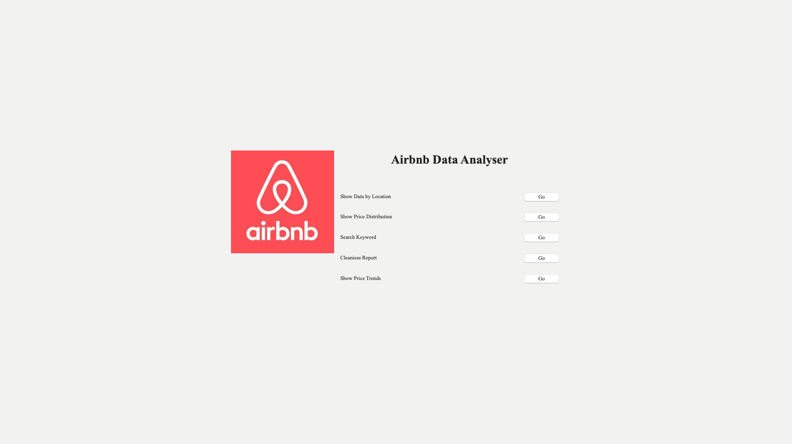



* Login Interface

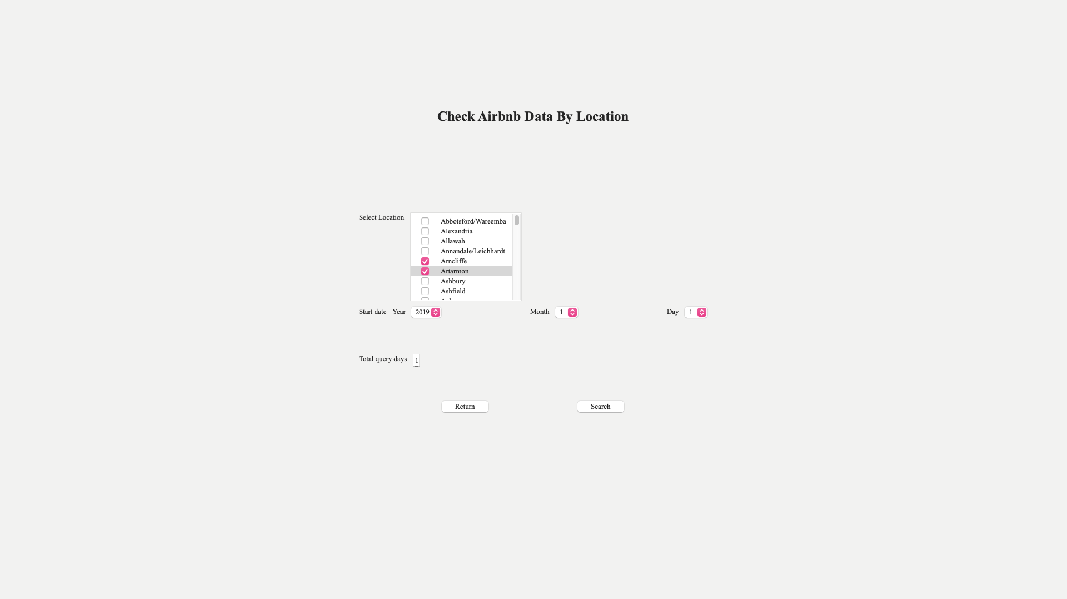

* Query Interface

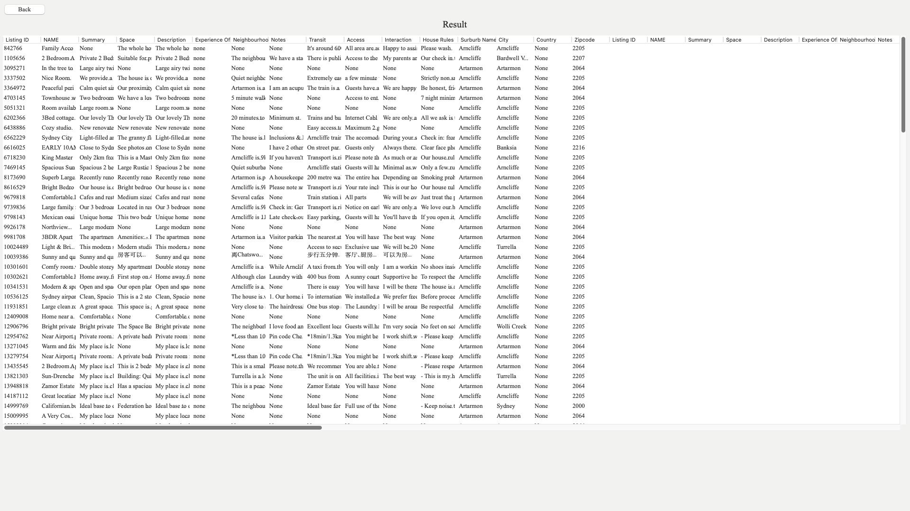

* Retrieve Property Listings
* Description:
* We have implemented a property search feature that allows users to find Airbnb listings based on various criteria. This functionality enables users to filter listings based on **Suburb List, date, and total query days.**
* Analysis Process:
* Data Preparation: We use the Airbnb dataset and create a database using files such as calendar_dec18.csv, listing_dec18.csv, and review_dec18.csv. The database includes tables like suburb, calendar, House, etc.
* Search Result Presentation: We present the search results in a **tabular view**, where we display property information that meets the search criteria. The table includes details such as property name, space, description, suburb name, location, and more.
* Results:
* Users can now easily use our property search feature. On the search results page, we return a list of properties and help users find suitable Airbnb listings based on their needs.
* Users can quickly narrow down their selection using suburb lists, dates, and total query days to find properties that best match their requirements.
* Analysis 2 <show price Distribution>

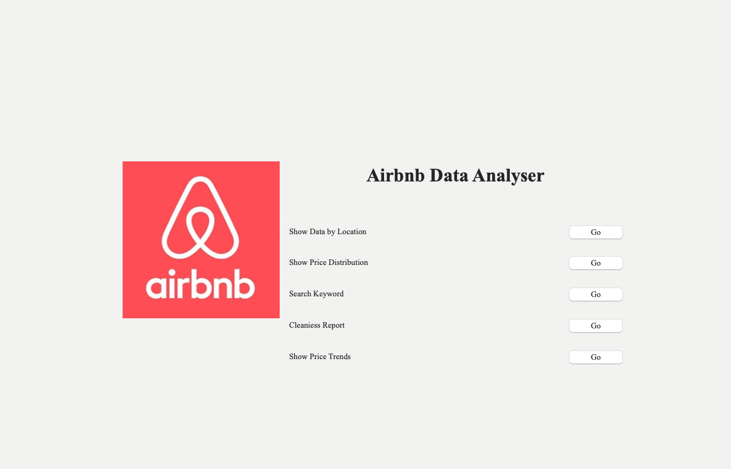



* Query Interface

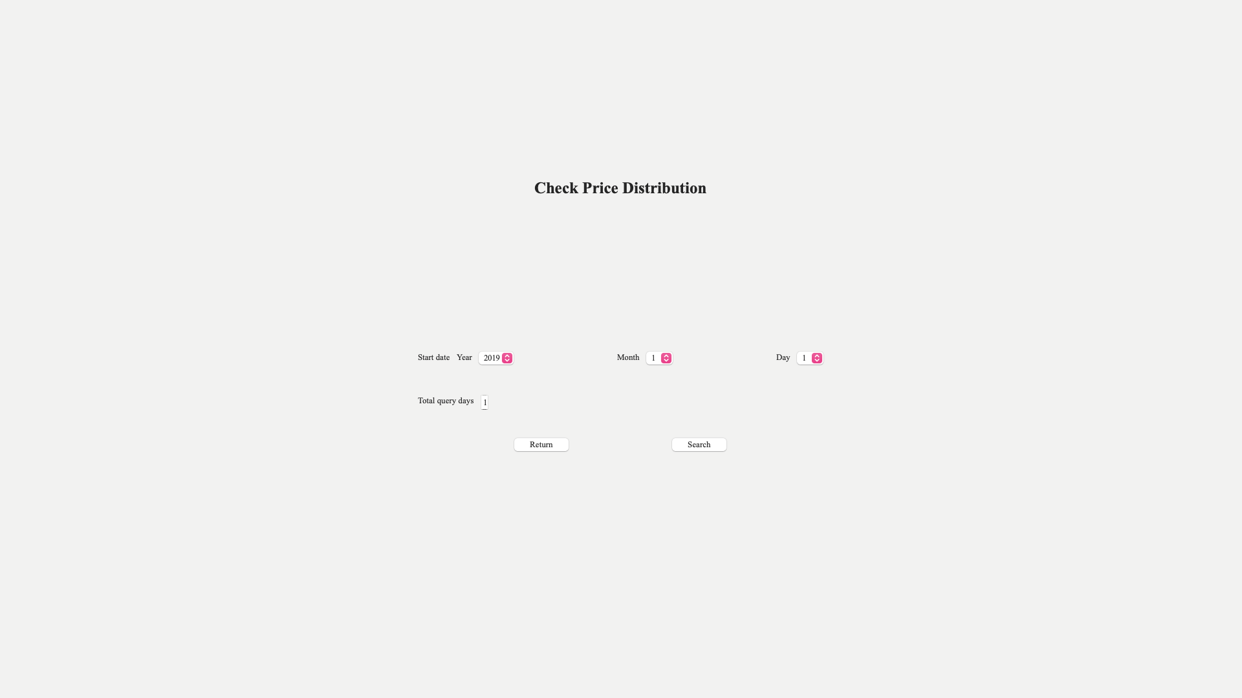

* Input Time Query

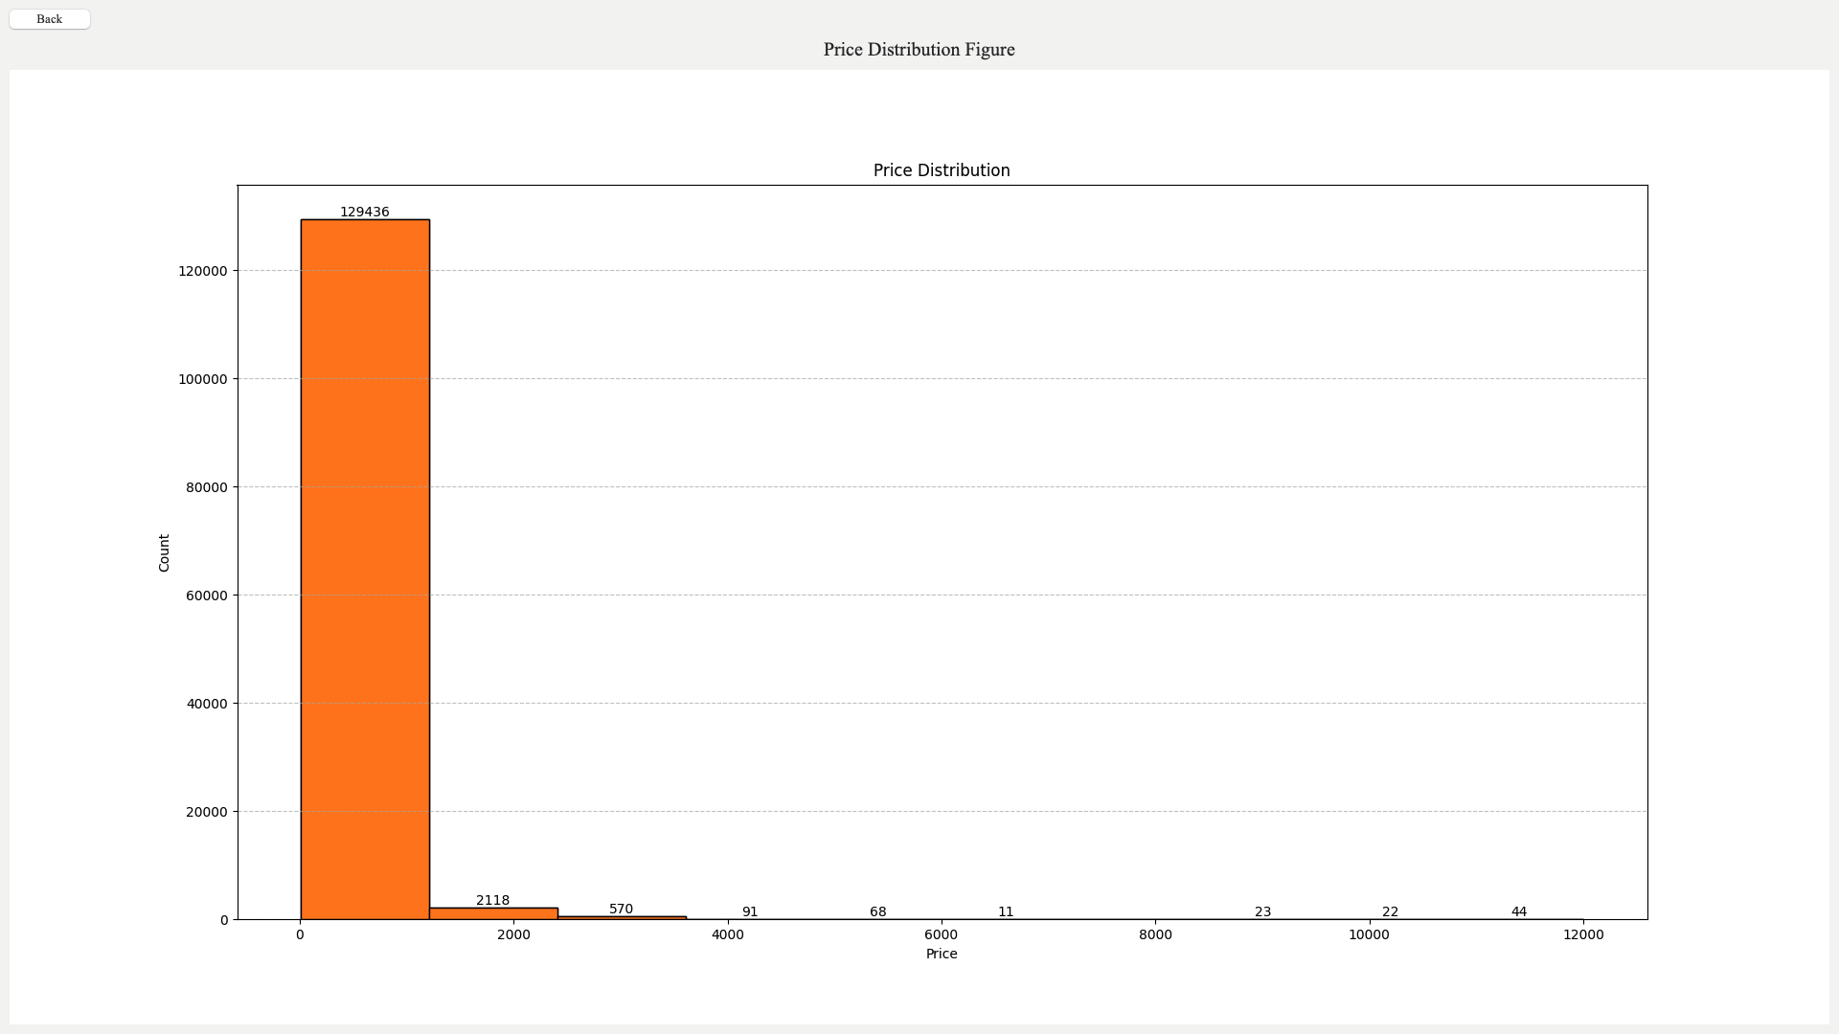

* Retrieve Price Distribution Graph
* Description:
* We have implemented a price distribution histogram feature that allows users to search for Airbnb listings based on various criteria. This feature can filter listings based on **date and total query days**.
* Analysis Process:
* Search Result Presentation: We return a **histogram** that displays where many listings fall within price ranges. We also label the quantity within each price range on the chart, allowing users to read the data more accurately.
* Results:
* **Data Visualization**: A histogram provides an intuitive way to visualize price data, and we label the quantity of listings within each price range on the chart. This enables users to quickly understand and analyze the data without having to go through extensive data tables.

# **Analysis 3 <Search keyword>**





* Query Interface

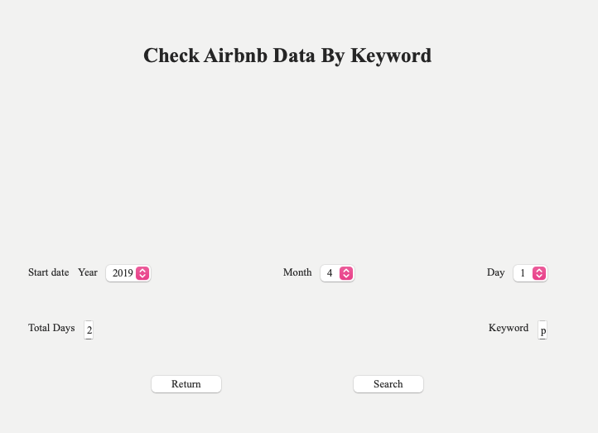

* Input Time & Keyword Query

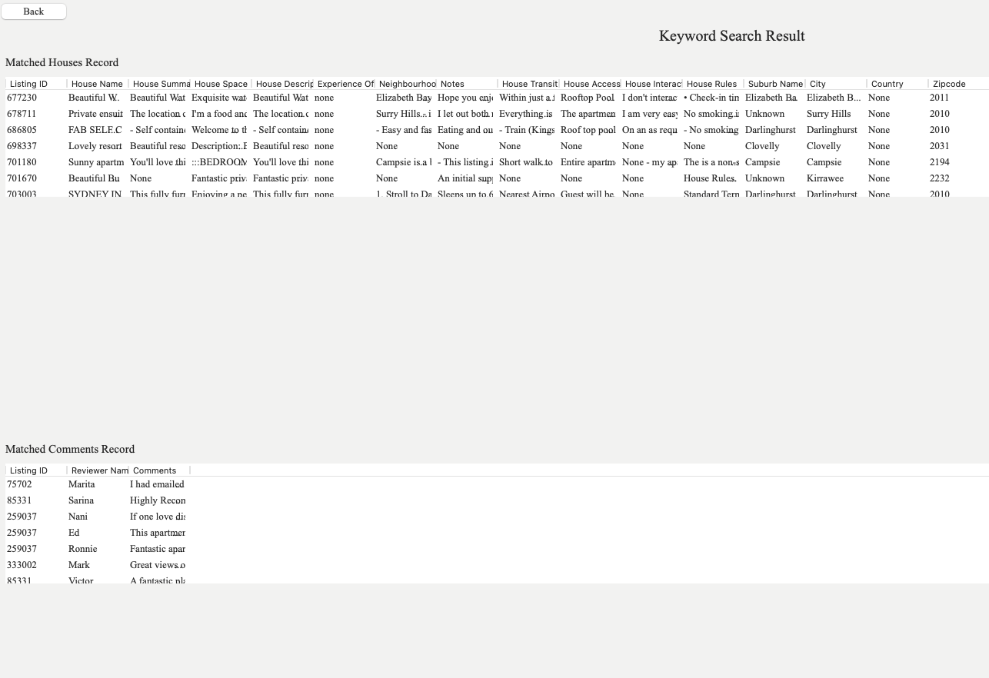

* Retrieve housing information matching the keywords.
* Description:
* We have implemented a keyword search feature that allows users to search for Airbnb listings based on various criteria. This feature can filter listings based on **date, total query days, and keywords.**
* Analysis Process:
* Search Result Presentation: A **list view** is provided, offering an option to display search results in a list format. In the list view, each listing can display some key information, and users can scroll through different listings.
* Results:
* Users can now quickly narrow down their selection of listings using suburb lists, dates, total query days, and keywords to find listings that best match their needs.

# **Analysis 4 <Cleaning Report>**



* Query Interface

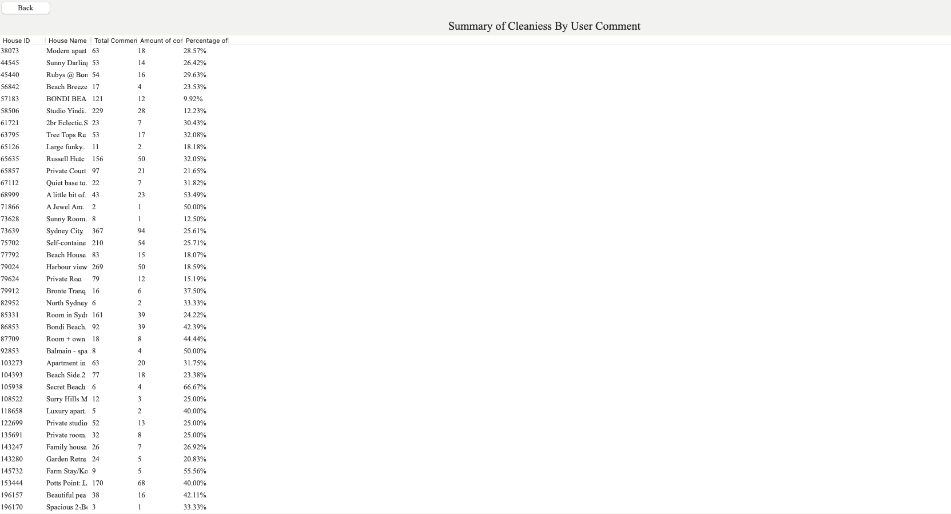

* Return summary of cleanliness list
* Description:
* We have implemented a cleanliness query feature that allows users to **click a button** to retrieve cleanliness satisfaction information about all the properties.
* Analysis Process:
* Result Presentation: A **table view** is provided, presenting cleanliness satisfaction data for all the properties. Each row represents a property, and columns may include the property's name, address, cleanliness rating, and other relevant information.
* Results:
* Users can also click on specific properties to view more detailed cleanliness ratings and other related information, providing a better understanding of the cleanliness of each property. This table view offers a clear and user-friendly way for **users to quickly assess and compare the cleanliness satisfaction of different properties.**

# **Analysis 5 <Price Tendency Figure>**



* Query Interface

* Query Interface

* Return Housing Price Trend Line Chart
* Description:
* We have implemented a housing price trend line chart feature that allows users to search for Airbnb listings based on various conditions. This feature can filter listings based on conditions such as **date, total query days, and suburb list.**
* Analysis Process: Result Presentation:
* **A line chart** is provided, generating price trend charts for one or multiple suburbs, which can be presented in a table or list view. This allows users to compare the price trends in different areas.
* Results:
* Users can filter listings based on criteria like date, total query days, and suburb list to generate corresponding price trend charts. Such visualization tools **help users gain a better understanding of the housing market in different regions and how prices change over time.**